** Press Release *** Press Release *** Press Release **
*********************
For Immediate Release

PERIODONTAL DISEASE…LIFE THREATENING
Local Dental Expert Appointed to Spread the Word

January 15, 2005
Dr. Lisa Marie Samaha, DDS, FAGD, PC
Port Warwick Dental Arts
Newport News, VA

Port Warwick Dental Arts, the practice of Lisa Marie Samaha, DDS, FAGD has recently been designated as an official Center for Dental Medicine. The first woman-owned practice to receive this honor, PWDA is now the 22nd center world-wide. Additionally, due to her extensive research and presentations to physicians and dentists during her 24 years in practice, Dr. Samaha has been appointed as the official spokesperson for The Centers for Dental Medicine. The mission of the CDM is to increase awareness and ensure dialogue amongst health care professionals and the general public with regards to the serious systemic complications of oral disease. In recognition of her appointment, Dr. Samaha has been asked to lecture to a discriminating group of doctors in Maui in January.
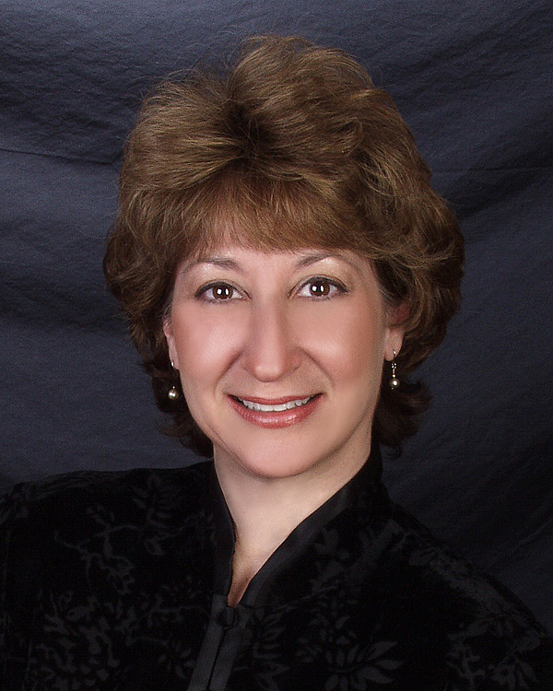
******************************

A New Center for Dental Medicine in Newport News, VA
Now Offering the Latest Non-Surgical Periodontal Disease Treatment

Periodontal disease (gum disease) is the number one infectious disease in America today and affects about 3 out of 4 adults. The devastating effects of periodontal disease on our total health are just beginning to be fully explored. Researchers have linked periodontal disease to most major deadly diseases and ailments, including: heart disease, strokes, diabetes, Alzheimer’s disease, respiratory disease, arthritis, premature birth, infertility, and even cancer. Treating periodontal disease may be the answer to preventing and treating many other major diseases and illness.

Periodontal disease occurs when neglected gums become swollen and pockets develop between the teeth and gum tissue. Bacteria live in the pockets and produce toxins which attack healthy gum tissue and bone. This results in an infection in the mouth that never heals. Periodontal disease, however, is not limited to just damaging gums, teeth, and bone. Bacteria in the pockets can enter the blood stream through the infected gum tissue and attack healthy organs and tissue in other parts of the body.

For decades it was believed that periodontal disease was caused simply by improper dental hygiene (lack of brushing and flossing). Treatment therefore centered around cleaning. The dentist or hygienist would perform mechanical debidement (scraping and cleaning of the teeth below the gum line to remove tarter, calculus, and food particles). They would also recommend more brushing and flossing. More severe cases were usually referred to a periodontist for gum surgery. Researchers now know that a variety of other factors can contribute to the periodontal disease process such as: certain bacteria, genetics, diet and nutrition, pregnancy, other diseases, medication, and aging. The Center for Dental Medicine’s comprehensive periodontal treatment program focuses on the entire disease process. Dentistry can now effectively treat periodontal disease and reverse much of the damage using non invasive treatment including lasers.

Researchers have discovered a serious health risk for people with periodontal disease who also have heart disease or who are diabetic. Periodontal disease is a major source of infection in the body. Infection produces a substance in the blood known as C-reactive protein. C-reactive protein can be detected by a simple blood test. Patients with elevated levels of C-reactive protein are at a substantially greater risk of heart attack or stroke. C-reactive protein is not just a passive bio-marker, but is an active antigen which causes clotting and may lead to a stroke or heart attack. Regular visits to the dentist to treat and control periodontal disease can be crucial to diabetics and heart patients.

Researchers do not yet fully understand all of the cause and effect relationships between periodontal disease and other systemic diseases. Treating periodontal disease has long been demonstrated to help diabetics manage their disease. We do know that periodontal infection depletes the body’s immune system defenses. Treating periodontal disease and removing a major source of infection would be beneficial to any person with health challenges.

After years of developing her own highly successful advanced periodontal treatment program, Dr. Lisa Marie Samaha has recently been asked to join hands with the Centers for Dental Medicine. After years of research and testing, the comprehensive treatment program combines her protocol with that of periodontist, Dr. John Hammer from Phoenix, AZ. The treatment includes periodontal screening, risk assessment, thorough cleaning, targeted nutritional therapy, laser decontamination, effective microbial control, follow-up treatment, and daily home care.

Dr. Samaha sees more impressive results using the combined periodontal treatment methods which include the implementation of a specialized laser. “We can now offer a periodontal treatment that gives even more measurable results that are a vast improvement over our previous advanced treatment hygiene program,” said Dr. Samaha. “Many patients can now avoid the unnecessary discomfort and cost associated with gum surgery.”

Treating periodontal disease can lower the risk of heart attacks, stroke, diabetic complications, lung diseases cancer and many other diseases. The comprehensive periodontal treatment program is very affordable and includes follow up visits and treatments to control the disease. Treating periodontal disease is a fraction of the cost of treating a major illness or even a short stay in the hospital. “We are not just saving teeth…we are helping people save money…we are helping to save lives,” says Bob Schulhof, President of Centers for Dental Medicine.

The Center for Dental Medicine is located at Port Warwick Dental Arts, in Newport News, Virginia.
Dr. Samaha can be reached directly at samahadds@pwdentalarts.com or via phone at 757-880-5156. Her dental office contact number is 757-223-9270.

